|  |  |  |  |  |
| --- | --- | --- | --- | --- |
|  | A | B | **C** | D |
| Aproximation |  |  |  |  |
| Log  Abs(Error) |  |  |  |  |
| Mean (error) | 0.0305 | 0.0330 | **0.0179** | 0.0506 |
| Max  (error) | 0.8181 in top left corner | 0.8134 in top left corner | **0.8024** in top left corner | 0.8134 in top left corner |

TRIÁNGULO

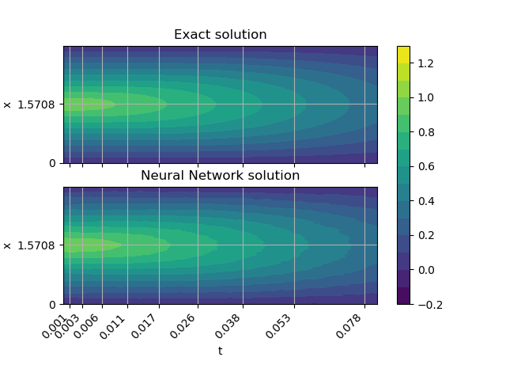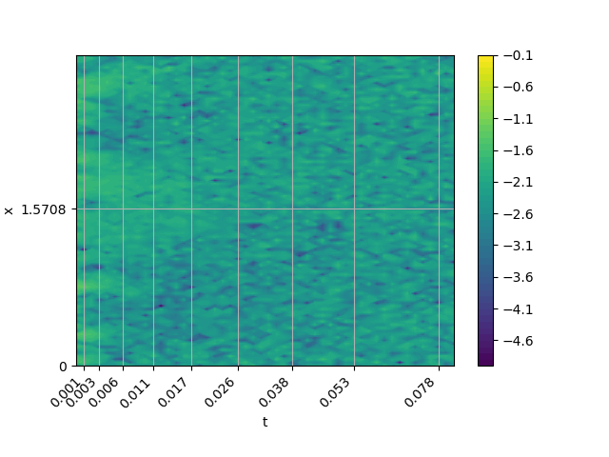

* Error máximo: 0.0447
* Error medio: 0.0055
* Error máximo sin t = 0: 0.03989

ESCALERA CON MARGEN

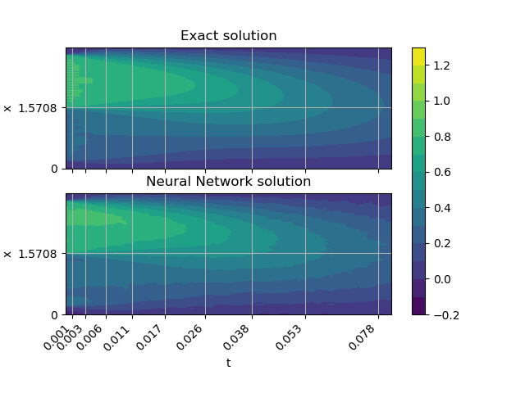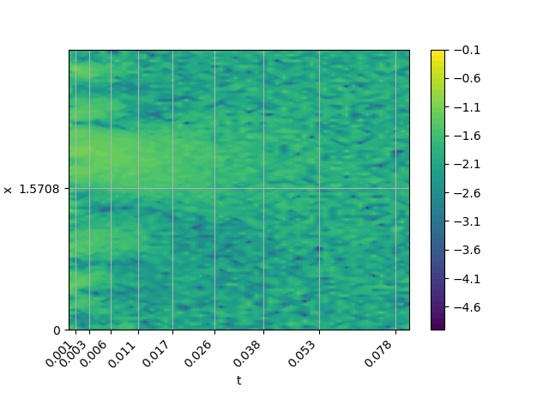

* Error máximo: 0.0915
* Error medio: 0.0132
* Error máximo sin t = 0: 0.0915

POLINOMIO

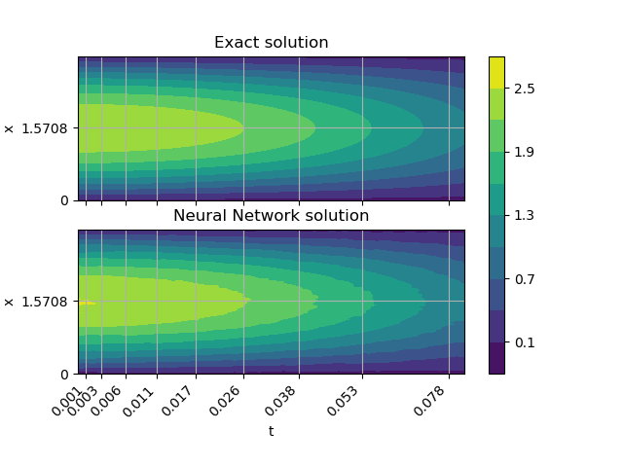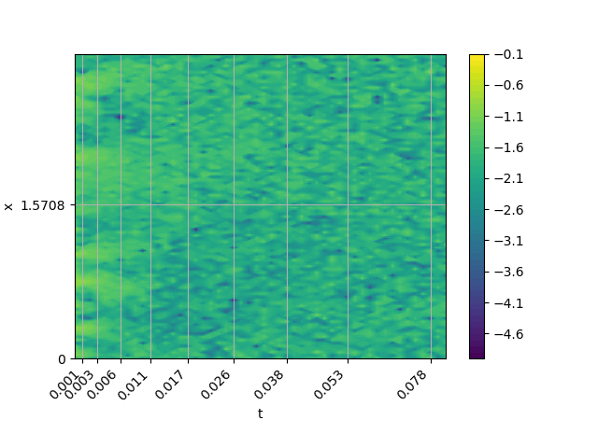

* Error máximo: 0.1177
* Error medio: 0.0156
* Error máximo sin t = 0: 0.1177